**Homework 6. Solutions**

Teacher: Paul Briard

Ex. 1.

A mass is vibrating in the $x$-direction at the end of a spring of spring constant $k=$ 225 N/m. The figure shows a graph of its position x as a function of time t. (a) At what times is the mass not moving? (it doesn’t mean the mass stop to move, it means its velocity is zero) (b) How much mechanical energy did this system originally contain? (the system here is an horizontal spring-mass system, the gravitational potential energy is not involved with this problem) (c) How much mechanical energy did the system lose between times $t=1.0$ s and $t=4.0$ s? Where did this energy go?

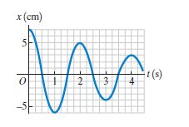

**Solution**

a.When $\left|x\right|$ is maximum, $v_{x}=\frac{dx}{dt}=0$ (the tangent to the curve $x(t)$ is horizontal), which occurs at $t=0.0 s$, $t=1.0 s$, $t=2.0s$, $t=3.0s$, $t=4.0s$.

b.

The mechanical energy is, at any time :

$$E_{m}=\frac{1}{2}kx^{2}+\frac{1}{2}mv_{x}^{2}$$

The mechanical energy is, when $\left|x\right|$ is maximum and $v_{x}=0$:

$$E_{m}=\frac{1}{2}kx^{2}$$

At the initial time $t=0$, $x=7.0 cm$, the mechanical energy is:

$$E_{0}=\frac{1}{2}\left(225 N.m^{−1}\right){\left(0.070 m\right)}^{2}=0.55 J$$

c) At time $t_{1}=1.0 s$, $v_{x}\left(t_{1}\right)=0$, $x\left(t_{1}\right)=−6.0 cm$, the mechanical energy is:

$$E_{1}=\frac{1}{2}k{x_{1}}^{2}=\frac{1}{2}\left(225 N.m^{−1}\right){\left(−0.060 m\right)}^{2}=0.405 J$$

At time $t_{4}=4.0 s$, $v_{x}\left(t_{4}\right)=0$, $x\left(t_{4}\right)=3.0 cm$, the mechanical energy is:

$$E_{4}=\frac{1}{2}k{x_{4}}^{2}=\frac{1}{2}\left(225 N.m^{−1}\right){\left(0.030 m\right)}^{2}=0.101 J$$

The mechanical energy “lost” is: $E_{1}−E_{4}=0.30 J$.This change of mechanical energy correspond to the work of the non-conservative forces (here the friction with the table, with the air resistance …).

Ex. 2. A sinusoidally varying driving force is applied to a damped harmonic oscillator. The amplitude of the driven oscillations is given by the following equation:

$$A=\frac{F_{max}}{\sqrt{{\left(k−mω_{d}^{2}\right)}^{2}+b^{2}ω_{d}^{2}}}$$

where $F_{max}$ is the maximum magnitude of the driving force, $k$ is the spring force constant involved with the oscillator, $m$ is the mass of the oscillator, $ω_{d}$ is the angular frequency of the driving oscillations and $b$ is the damping constant. (a) What are the units of the damping constant b? (b) Show that the quantity $\sqrt{km}$ has the same units as b. (c) In terms of $F_{max}$ and $k$, what is the amplitude for when (i) $b=0.2\sqrt{km}$ and (ii) $b=0.4\sqrt{km}.$

**Solution**

a.To find the units of $\sqrt{km}$ we can consider the special case: $k−mω_{d}^{2}=0$, i.e.

$$A=\frac{F_{max}}{bω_{d}}$$

Then

$$b=\frac{F_{max}}{Aω_{d}}$$

The units of $F_{max}$ is $kg.m.s^{−2}$ (you can remember easily $1N=1 kg.m.s^{−2}$ if you remember the Newton’s second law), unit of $A$ is $m$, unit of $ω_{d}$ is $s^{−1}$ ( $rad.s^{−1}$ is also right, but an angle expressed in rad is the ratio between two quantities in same unit).

Then, the units of $F_{max}/Aω_{d}$, which are also the unit of $b$ are:

$$\frac{ kg.m.s^{−2}}{\left(m\right)(s^{−1})}=kg.s^{−1}$$

**Comment:** it is not an obligation to consider the particular case, $A=F_{max}/(bω_{d} )$, you could also say “according the equation which describe $A$, the units of $A$ are the same than the units of $F/(bω_{d} )$. ”. We can say this because the quantities ${\left(k−mω_{d}^{2}\right)}^{2}$, $b^{2}ω_{d}^{2}$, and ${\left(k−mω_{d}^{2}\right)}^{2}+b^{2}ω_{d}^{2}$ must have the same units.

b. The spring force constant $k$ is expressed in $N.m^{−1}$. The mass is expressed in $kg$. The units of $\sqrt{km}$ are:

$${\left[N.m^{−1}.kg\right]}^{1/2}={\left[kg.m.s^{−2}.m^{−1}.kg\right]}^{1/2}={\left[{kg}^{2}.{kg}^{−2}\right]}^{1/2}=kg.s^{−1}$$

c.

For $ω_{d}=\sqrt{k/m}$,

$$A=\frac{F_{max}}{b}\sqrt{\frac{m}{k}}$$

(i) $b=0.2\sqrt{km}$,

$$A=\frac{F_{max}}{0.2\sqrt{km}}\sqrt{\frac{m}{k}}= \frac{F_{max}}{0.2 k}=5.0 \frac{F_{max}}{k}$$

(ii) $b=0.4\sqrt{km}$

$$A=\frac{F_{max}}{0.4\sqrt{km}}\sqrt{\frac{m}{k}}=\frac{F_{max}}{0.4 k}=2.5 \frac{F_{max}}{k}$$

**Comment:** You can compare your results with the following graph. As seen on the graph, the amplitude is maximum when the driving angular frequency $ω_{d}$ is near the natural angular frequency of the oscillator ($ω=\sqrt{k/m}$)

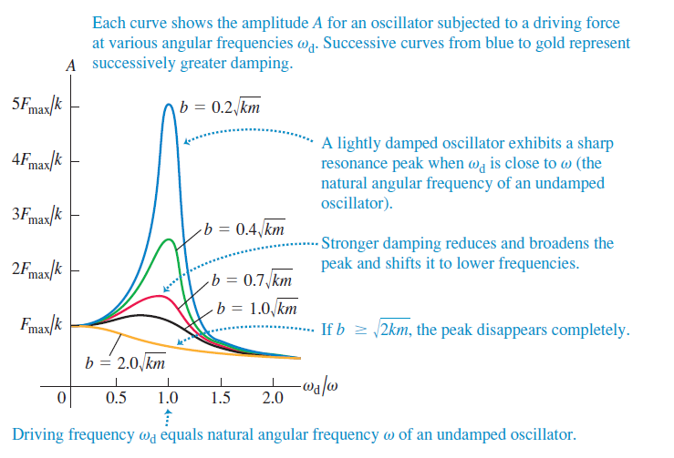

Ex. 3. On a frictionless, horizontal air track, a glider of mass $m$ oscillates at the end of an ideal spring of force constant (also named spring coefficient) $k=250 N.m^{−1}$. The graph shows the acceleration of the glider as a function of time. (a) Describe the acceleration of the glider in respect with its x-coordinate $x(t)$, $k$, $m$ ( $x=0$ is the position of equilibrium, and then in respect with the amplitude $A$, the angular velocity $ω$ and phase angle $ϕ$ of the simple harmonic motion describing $x(t)$. Find (b) the mass of the glider (unit: $kg$); (c) the maximum displacement of the glider from the equilibrium point (unit: m); (d) the maximum force the spring exerts on the glider (unit: N).

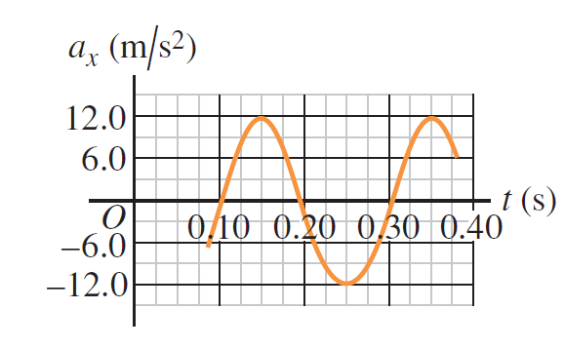

Solution:

(a)

Using the Newton’s law for an horizontal motion of a glider (friction ignored), along the x-axis:

$$ma_{x}=−kx$$

$$a_{x}(t)=−\frac{k}{m}x(t)$$

$$a_{x}\left(t\right)=−\frac{k}{m}Acos\left(ωt+ϕ\right)$$

(b)

The acceleration oscillate at the same angular velocity than $x(t)$, i.e. $ω=\sqrt{k/m}$

$$T=\frac{2π}{ω}=2π\sqrt{m/k}$$

We obtain:

$$m=k{\left(\frac{T}{2π}\right)}^{2}$$

$$m=k{\left(\frac{T}{2π}\right)}^{2}$$

$$m=\left(250 N.m^{−1}\right){\left(\frac{0.20 s}{2π}\right)}^{2}=0.253 kg$$

(c)

$$a_{x}\left(t\right)=−\frac{k}{m}x(t)=−\frac{k}{m}Acos\left(ωt+ϕ\right)$$

$$a_{x,max}=−\frac{k}{m}x_{max}=−\frac{k}{m}A$$

The maximum acceleration is:

$$a_{max}=\frac{k}{m}A$$

$$A=x_{max}=\frac{ma_{max}}{k}=\frac{\left(0.253 kg\right)\left(12.0 m.s^{−2}\right)}{250 N.m^{−1}}=0.0121 m$$

(d)

$$F_{max}=kA=ma_{max}=\left(0.253 kg\right)\left(12.0 m.s^{−2}\right)=3.04 N$$

**Ex. 4.** A thin metal disk with mass $m=2.00×{10}^{−3} kg$ and radius 2.20 cm is attached at its center to a long fiber as seen on the figure. The disk, when twisted and released at time t = 0, oscillates with a period of $T = 1.00 s$. (1) All frictions are ignored. A restoring torque due to the torsion of the fiber about the pivot $τ=−κθ$ is exerted on the disk, where $κ$ is the torsion constant of the fiber and $θ(t)$ is the angular displacement of the disk (the angular displacement from equilibrium, at equilibrium $θ=0$). Describe the angular acceleration of the disk in terms of angular displacement of the disk when its oscillates. (2) Why we can say that the disk has an angular SHM ? Describe this SHM $θ(t)$ in terms of $θ_{A}$ the angular amplitude of the SHM, $ω$ the angular frequency of the SHM, the time t and the phase at origin $ϕ$. (3) Describe the angular frequency of the SHM $ω$ and then its period T in terms of moment of inertia $I$ about the axis of rotation of the disk and the torsion constant $κ$ (4) Calculate the value of the torsion constant $κ$ of the fiber (unit: $N.m$). About the description of moment of inertia of the disk about its axis, you don’t need to demonstrate its expression, you can use a previous result.

**Hint:** Take care that here $ω≠\frac{dθ}{dt}$. There are two kinds of angles and two kinds of angular velocities. The angular frequency of the SHM is not the angular velocity of the disk.

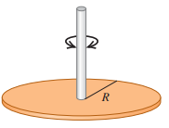

**Solution**

(1) Rotational analog of the Newton second law:

$$\vec{τ}=I\vec{α}$$

where $\vec{τ}$ is the net torque on the disk about pivot, $I$ is the moment of inertia about the axis of rotation, $\vec{α}$ is the angular acceleration vector.

We obtain:

$$τ=I\frac{d^{2}θ}{{dt}^{2}}$$

The restoring torque is also the net torque exerted on the disk (the gravity don’t exert a torque here and the friction forces are ignored). We obtain:

$$I\frac{d^{2}θ}{{dt}^{2}}=−κθ$$

$$\frac{d^{2}θ}{{dt}^{2}}=−\frac{κ}{I}θ$$

Or

$$\frac{d^{2}θ}{{dt}^{2}}+\frac{κ}{I}θ=0$$

(2) There is an angular SHM because the angular acceleration is proportional with the angular displacement. The angular displacement, is described as follows:

$$θ\left(t\right)=θ_{A}\cos{(ωt+ϕ)}$$

The differential equation can be described as follows:

$$\frac{d^{2}θ}{{dt}^{2}}+ω^{2}θ=0$$

We obtain the expression of the angular frequency of the SHM:

$$ω=\sqrt{\frac{κ}{I}}$$

$$ω=\frac{2π}{T}$$

where T is the period of the angular SHM. We obtain:

$$\frac{2π}{T}=\sqrt{\frac{κ}{I}}$$

$$T=2π\sqrt{\frac{I}{κ}}$$

(4) The torsion constant is described as follows:

$$\frac{2π}{T}=\sqrt{\frac{κ}{I}}$$

$$κ={\left(\frac{2π}{T}\right)}^{2}I$$

The moment of inertia of the disk about its axis of rotation is:

$$I=\frac{1}{2}MR^{2}$$

where M is the mass of the disk and R its radius. We obtain:

$$κ={\left(\frac{2π}{T}\right)}^{2}\frac{1}{2}MR^{2}={\left(\frac{2π}{1.00 s}\right)}^{2}\frac{1}{2}\left(2.00×{10}^{−3} kg\right){\left(2.20×{10}^{−2} m\right)}^{2}$$

$$κ=1.91×{10}^{−5}N.m.$$

About checking the units, $1 N=1 kg.m.s^{−2}$, thus $1 N.m=1 kg.m^{2}.s^{−2}$

About the unit of the torsion constant, if you check the expression of the restoring torque (the magnitude of a torque is expressed in N.m), you will find $N.m.{rad}^{−1}$ as unit for the torsion constant $κ$.

And from the expression of the torsion constant $κ=ω^{2}I$ we could also describe the unit of the torsion constant as ${rad}^{2}.kg.m^{2}.s^{−2}$ or ${rad}^{2}.N.m$. There is no contradiction and both units are right (N.m as unit is also right), because the radian is dimensionless.

An angle is a dimensionless quantity. An angle expressed in radians is the ratio between two lengths expressed in same unit (for instance $2π$ rad is the ratio between the circumference of a disk $2πR$ and its radius $R$).